**Prerequisites:**

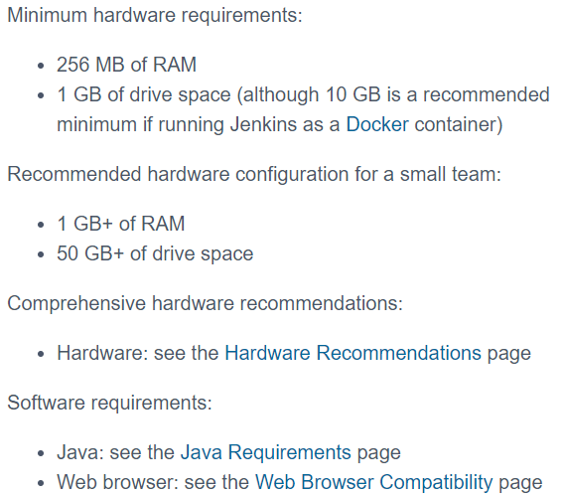

**Installation methods:**

**There are many ways to install Jenkins as below**

* **Running as a docker container**
* **Downloading war file and run in directly as below**

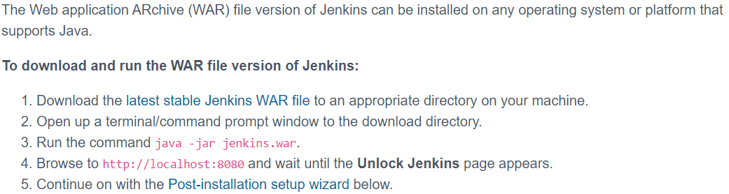

* **Download war file and deploy it in tomcat server**
* **Or download the Jenkins as a service**

**Jenkins as a service:**

* **sudo wget -O /etc/yum.repos.d/jenkins.repo** [**https://pkg.jenkins.io/redhat-stable/jenkins.repo**](https://pkg.jenkins.io/redhat-stable/jenkins.repo)
* **sudo rpm --import** [**https://pkg.jenkins.io/redhat-stable/jenkins.io.key**](https://pkg.jenkins.io/redhat-stable/jenkins.io.key)
* **Yum install Jenkins**

Run the above commands to install Jenkins

/var/lib is Jenkins home location

* Create a security group with port 8080 and we can access Jenkins with public IP of the instance as below
* **Publicip:8080**
* We can change the admin password under configuration settings
* We need to set java location under global tool configuration settings

**Config files for installing Jenkins in tomcat:**

**DEV**

**PROD**

**Start/stop Jenkins:**

* **Sudo service Jenkins start** (to start the jenkins) (start/stop/restart)
* **Ps -ef|grep Jenkins** (to check the status)
* **Service Jenkins status** (to check the status)
* **Service Jenkins stop** (to stop the Jenkins)

**Uninstall Jenkins:**

* **sudo service jenkins stop**
* **sudo yum remove jenkins**

**post installation:**

* we need to unlock the jenkins from console
* once the installation completed, we can access the Jenkins from browser and copy the initial admin password from **“/var/lib/Jenkins/secrets/initialAdminPassword”** to unlock the Jenkins

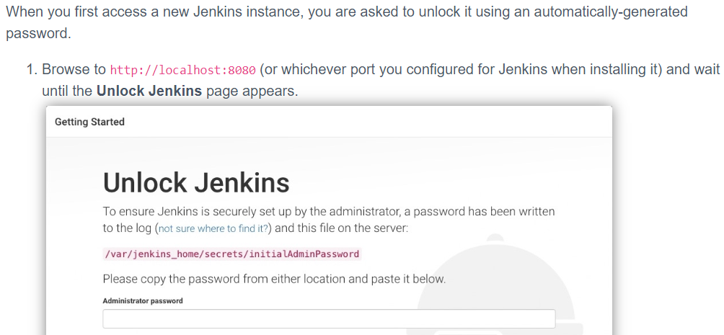

* Then in next step, we can install all the suggested plugins

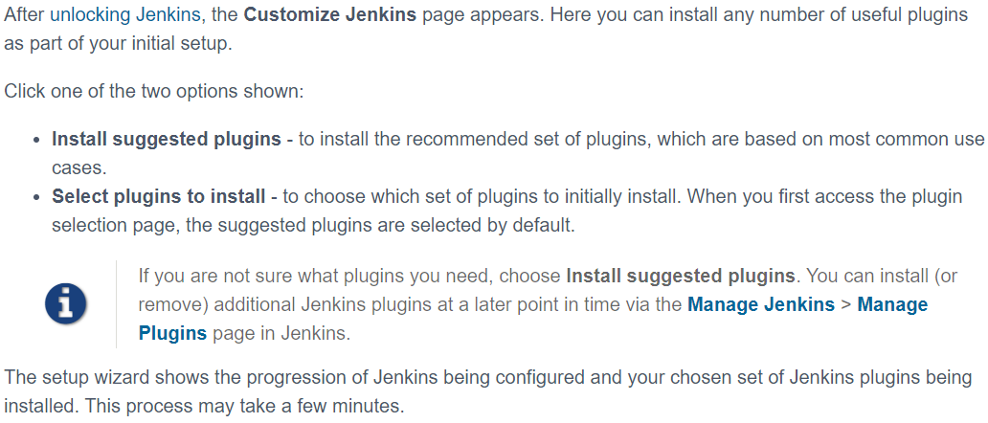

* Finally, we need to create admin user. If we don’t create, then we must use the initalAdminPassword to login again

